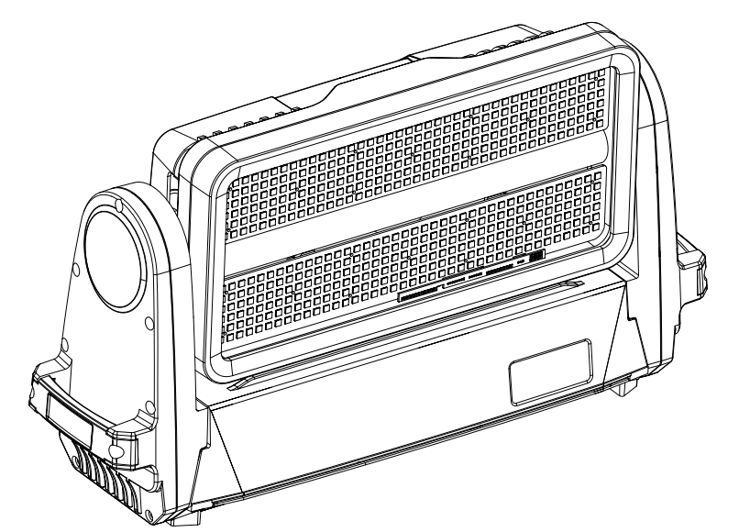

8 Segment LED Tilt Moving Strobe

This product manual contains important information about the safe installation and use of the light. Please read and follow these instructions carefully and keep this manual in a safe place for future reference.

Content

Safety instructions | 3
Fixture structure and Installation | 4
Signal and power connection | 5
Function setting | 6
DMX address setting | 6
Operation Menu | 7
DMX Channel | 9-12
Maintenance | 13
Trouble shooting | 13
Technical Data | 14-15

Every unit is tested completely and packed properly by the manufacturer. Please make sure the packing and / or the unit are in good condition before installation and use. Should there be any damage caused by transportation, consult your dealer and do not use the unit. Any damage caused by improper use will not be assumed by the manufacturer and / or dealer.
Please note that as part of our ongoing commitment to continuous product development, specifications are subject to change without notice.

ACCESSAORIES

These items are packed together with the light:：
Name | Quantity | Unit | Remarks
clamps | 2 | Pcs
Safety cord | 2 | Pcs
Using manual | 1 | Pcs

Safety instructions

When unpacking and before disposing of the carton check there is no transportation damage before using the light. Should there be any damage caused by transportation, consult your dealer and do not use the apparatus.

The projector is for indoor and outdoor use, IP65.
Do not install the fixtures onto inflammable surfaces directly.

The fixture is only intended for installation, operation and maintenance by qualified personnel.

Do not project the beam onto inflammable surfaces, minimum distance is 3meter. 3m

Avoid direct exposure to the light from the lamp. The light is harmful to the eye.

Do not attempt to dismantle and/or modify the projector in any way.

Electrical connection must only be carried out by qualified personnel.

Before installation, ensure that the voltage and frequency of power supply match the power requirements of the fixture.

It is essential that each projector is correctly earthed and that electrical installation conforms to all relevant standards.

Do not connect this device to any other types of dimmer apparatus.

The projector should always be installed with a secondary safety fixing. A safety cord is supplied for this; it should be attached as
shown in “installing the projector” section.

Shields and lens shall be changed if they have become visibly damaged to such an extent than their effectiveness is impaired, for
example by cracks or deep scratches.

Exterior surface temperatures of the luminaire after 5 minutes operation is 45℃, when steady state is achieved 70℃
There is no user serviceable parts inside the projector, do not open the housing and never operate the fixture with the covers
removed.

If you have any questions, don’t hesitate to consult your dealer or manufacturer.

Always disconnection from Power before the device’s installation, cleaning and maintenance！
INSTALLATIONS

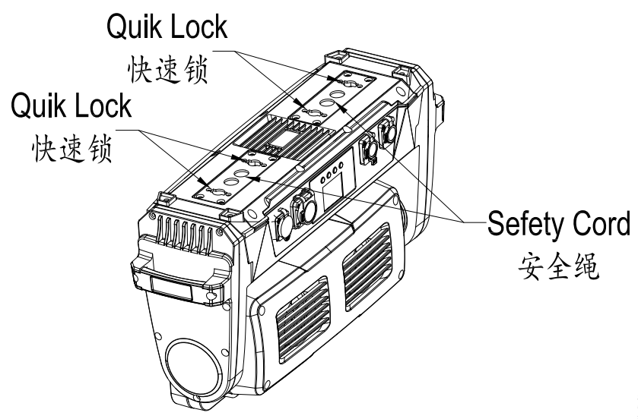

Take out 2 clamps and 1 safety rope, install the 2 clamps on the bottom of the fixture with the 4 quick knob attached to the clamps , then hang the fixture on the fixed support with the clamp, and tighten the clamp lock bolt to fix the fixture. Please confirm that the fixture installation is stable and reliable, and ensure that the hoisting position has sufficient strength to withstand the weight of the fixture. please carry the randomly equipped safety rope through the bottom of the fixture holder for auxiliary hoisting to ensure safety.
Warn：
1、The clamps are only used when install the fixtures. It is strictly forbidden to use the clamps as a handle to carry the fixtures.
2、For safety reasons, please use a safety rope that can withstand 10 times the weight of the fixture through the safety hole of the fixture body.
3、Side hang the fixtures are forbidden .

Signal and power connection

For the connection of control signals, 2-pin shielded cables with a diameter not less than 0.5 mm must be used between the fixture and the controller and between the fixtures. Please use the 3-pin signal output / incoming line of the lamp to connect. The connections between the 3-pin signal line ports are shown in the figure above. It must be noted that the 3 pin of the XLR plug / socket must not be in contact with the inner shell or between the cores when connecting. The XLR plug / socket and the XLR control cable cannot be connected in any other way than the connection shown in the figure above. This product receives the international standard DMX512 (1990) control signal.
The signal connection of multiple fixtures, the maximum number of connection is 32 fixtures, use a 3-pin signal cable from the DMX output port of the controller to the DMX input line of the 1st fixture, and connect from the DMX output line of the first fixture To the DMX input line of the second fixture, and so on, until all the fixtures are connected.
When the first fixture is not connected to the controller (the signal line connection between the other fixtures remain unchanged), it is the connection mode of master-slave synchronous control. However, to achieve master-slave synchronization control, the first fixture should be set as the master in the menu, and the remaining fixtures should be set as slaves (the default value is slave).

When connecting the power supply, the power supply of each fixture should be connected separately. Please note that the power supply voltage and frequency must match with the power supply voltage and frequency listed in the product manual.

Function Setting
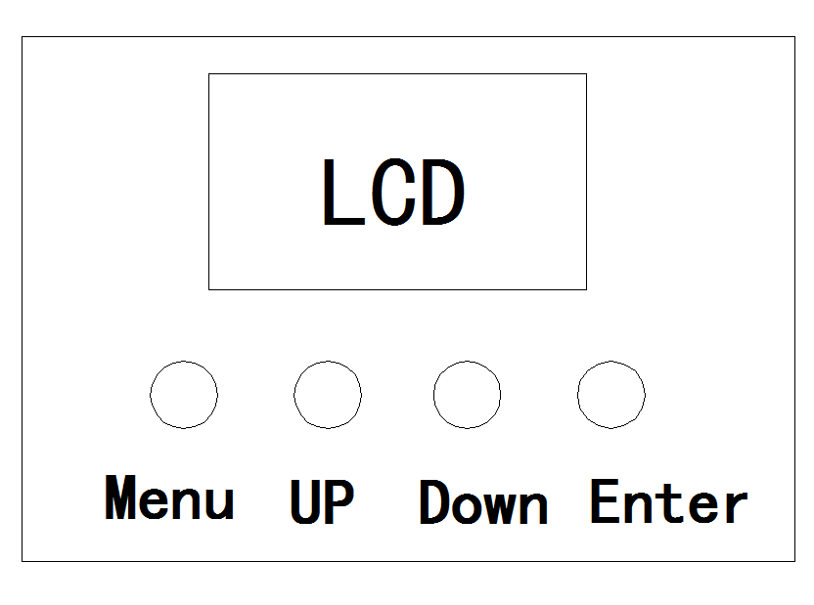
Press button UP or DOWN if you want to browse through the various Setup Options.
Press button ENTER to save your settings or enter the next menu.
Press button UP or DOWN to shift.
Press button Menu will return to the upper menu one by one.

DMX address Setting

When using the controller to control multiple fixtures，each fixture shall be provided with a DMX address to receive signals from the controller and respond correctly, There are 3 control modes in this product, which are simple mode, standard mode and extent mode.
For example: The fixture has 20 channels at standard mode
We set the 1st fixture :DMX Address 001，
Then the 2nd fixture DMX Address 021，the 3rd fixture DMX Address 041，
the 4th fixture 61，… …and so on.

Turn on the fixture，If operating menu is locked，press ENTER for 5 Sec, the fixture will be unlocked；
Then press Menu 、or UP or DOWN to find AddR menu；
Press ENTER ，display DMX Address；
Press UP / DOWN set DMX Address value；
Press ENTER to confirm，then the fixture automatically saved this DMX address
Press Menu will return to the upper menu

Operation Menu

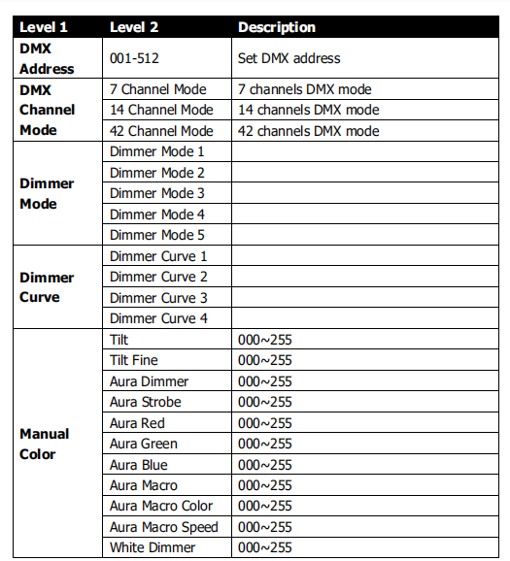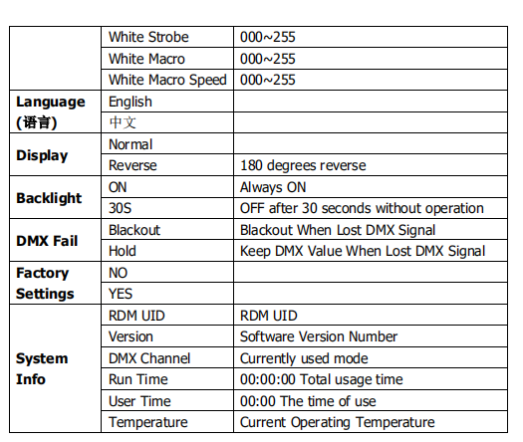

Remarks：
1. Only one fixture can be set to host in one signal line, remove DMX control signal when using host function

- In the synchronous control of multiple fixtures parameters can be transmitted from the master including: DMX mode, display setting, operation mode (user memory data included); All fixtures accepting parameters will automatically be set to slave mode.

DMX CHANNEL LIST
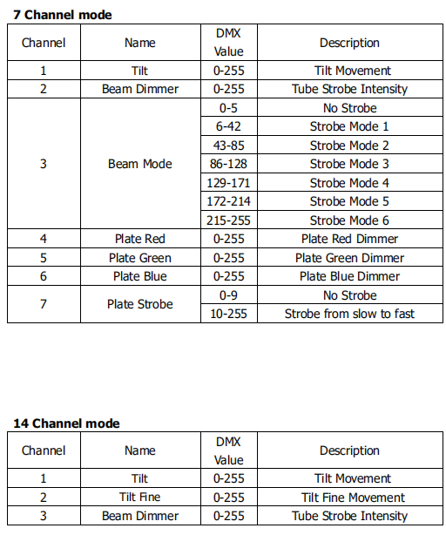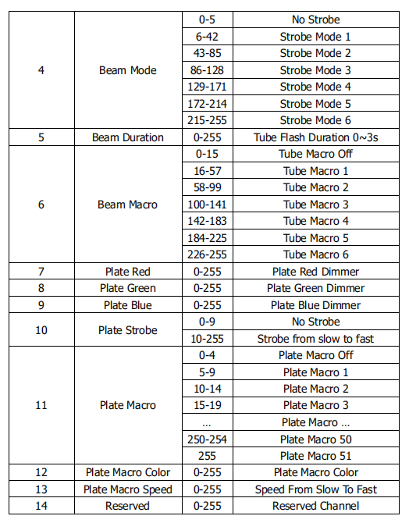

42 Channel mode
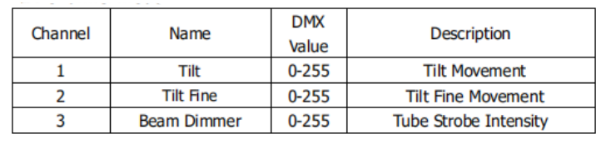
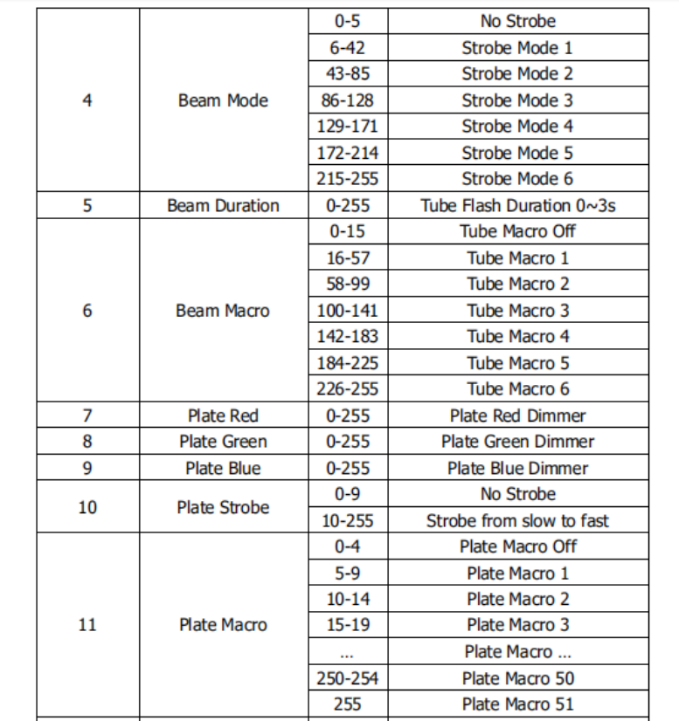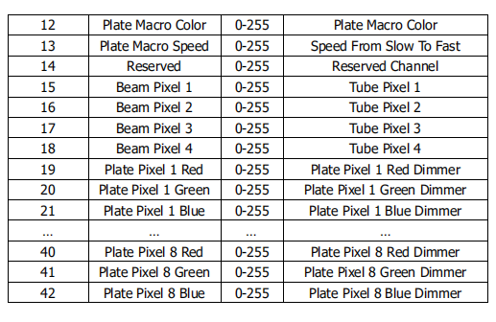

Channel priority: dimming> built-in program call > user program call>ARGBW dimming >HSV dimming> Macro Instruction> Color Temperature

Maintenance

To ensure the reliability of the projector it should be kept clean. It is recommended that the fans should be cleaned every 15 days. The lens and dichroic color filters should also be regularly cleaned to maintain an optimum light output. Do NOT use any type of solvent on dichroic color filters.

Cleaning frequency depends on the environment in which the fixture operates: damp, smoke or particularly dirty surroundings can cause greater accumulation of dirt on the unit’s optics. A soft cloth and typical glass cleaning products should be used in cleaning. It is recommended to clean the external optics at least once every 20 days and clean the internal optics at least once every 30 / 60 days.

Do not use any organic solvent, e.g. alcohol, to clean the reflector mirror, dichroic color filters or housing of the apparatus.

Trouble Shooting

PROBLEM | ACTION
The fixture wont switch on properly | - power cord connection is not normal  - the switching power supply is damaged or the connection is not normal, professional qualified technician needed to carry out maintenance and repair  - control board connection is not normal，professional qualified technician needed to carry out maintenance and repair
The fixture switch on，but LED not bright and not controlled | - LED board connection is not normal，professional qualified technician needed to carry out maintenance and repair
Switch on and light normally，but not controlled by controller | - check the DMX starting address code setting is correct or not , Check the XLR signal line is damaged or not
The fixture is dim and the brightness drops sharply | - The fixtures temperature is too high, please take necessary ventilation and heat dissipation measures

Technical Data

Input Voltage：
100V/120V/200V/220V /230V/240V AC，50/60Hz
Power rating：
1000W@220V
LED light source：
Strobe | 144pcs*5w Cold White LEDs
Surface effect | 480pcs *0.5w 5050 RGB 3in1 LEDs
Life | 50000 hour
Effect：
Middle white light strobe 4 segment control
Background effects on each side are divided into 4 sections（2x4）
Variable Speed Two-way Rainbow Effect Color Flow Effect
Dimmer：
0-100% linear dimming
Strobe：
Electric Strobe，0.3-20pcs/Sec Max 20 Hz

Tilt rotation：
Tilt 185°
Control mode：
International standard DMX512 signal，3Pin(5Pin)DMX512 XLR RDM

Dmx Channels：
Simple mode :7CH，Standard mode 14CH，Extension mode 42CH

Master-slave synchronous control mode
Stand-alone mode
Self-checking mode
Other functions：
Tilt speed adjustable
Display fixtures Using Time
Display Software Version
Maintainable modular structure
Speed-regulating radiator
Housing and Protection rate：
High strength magnesium alloy, IP65 color: black (white optional)

Working temperature：
-20°C～40°C
Weight：
N.T.: 12.5Kg 27lb
Product Size：
See at below details：

