Follow Spot 380W DMX Control

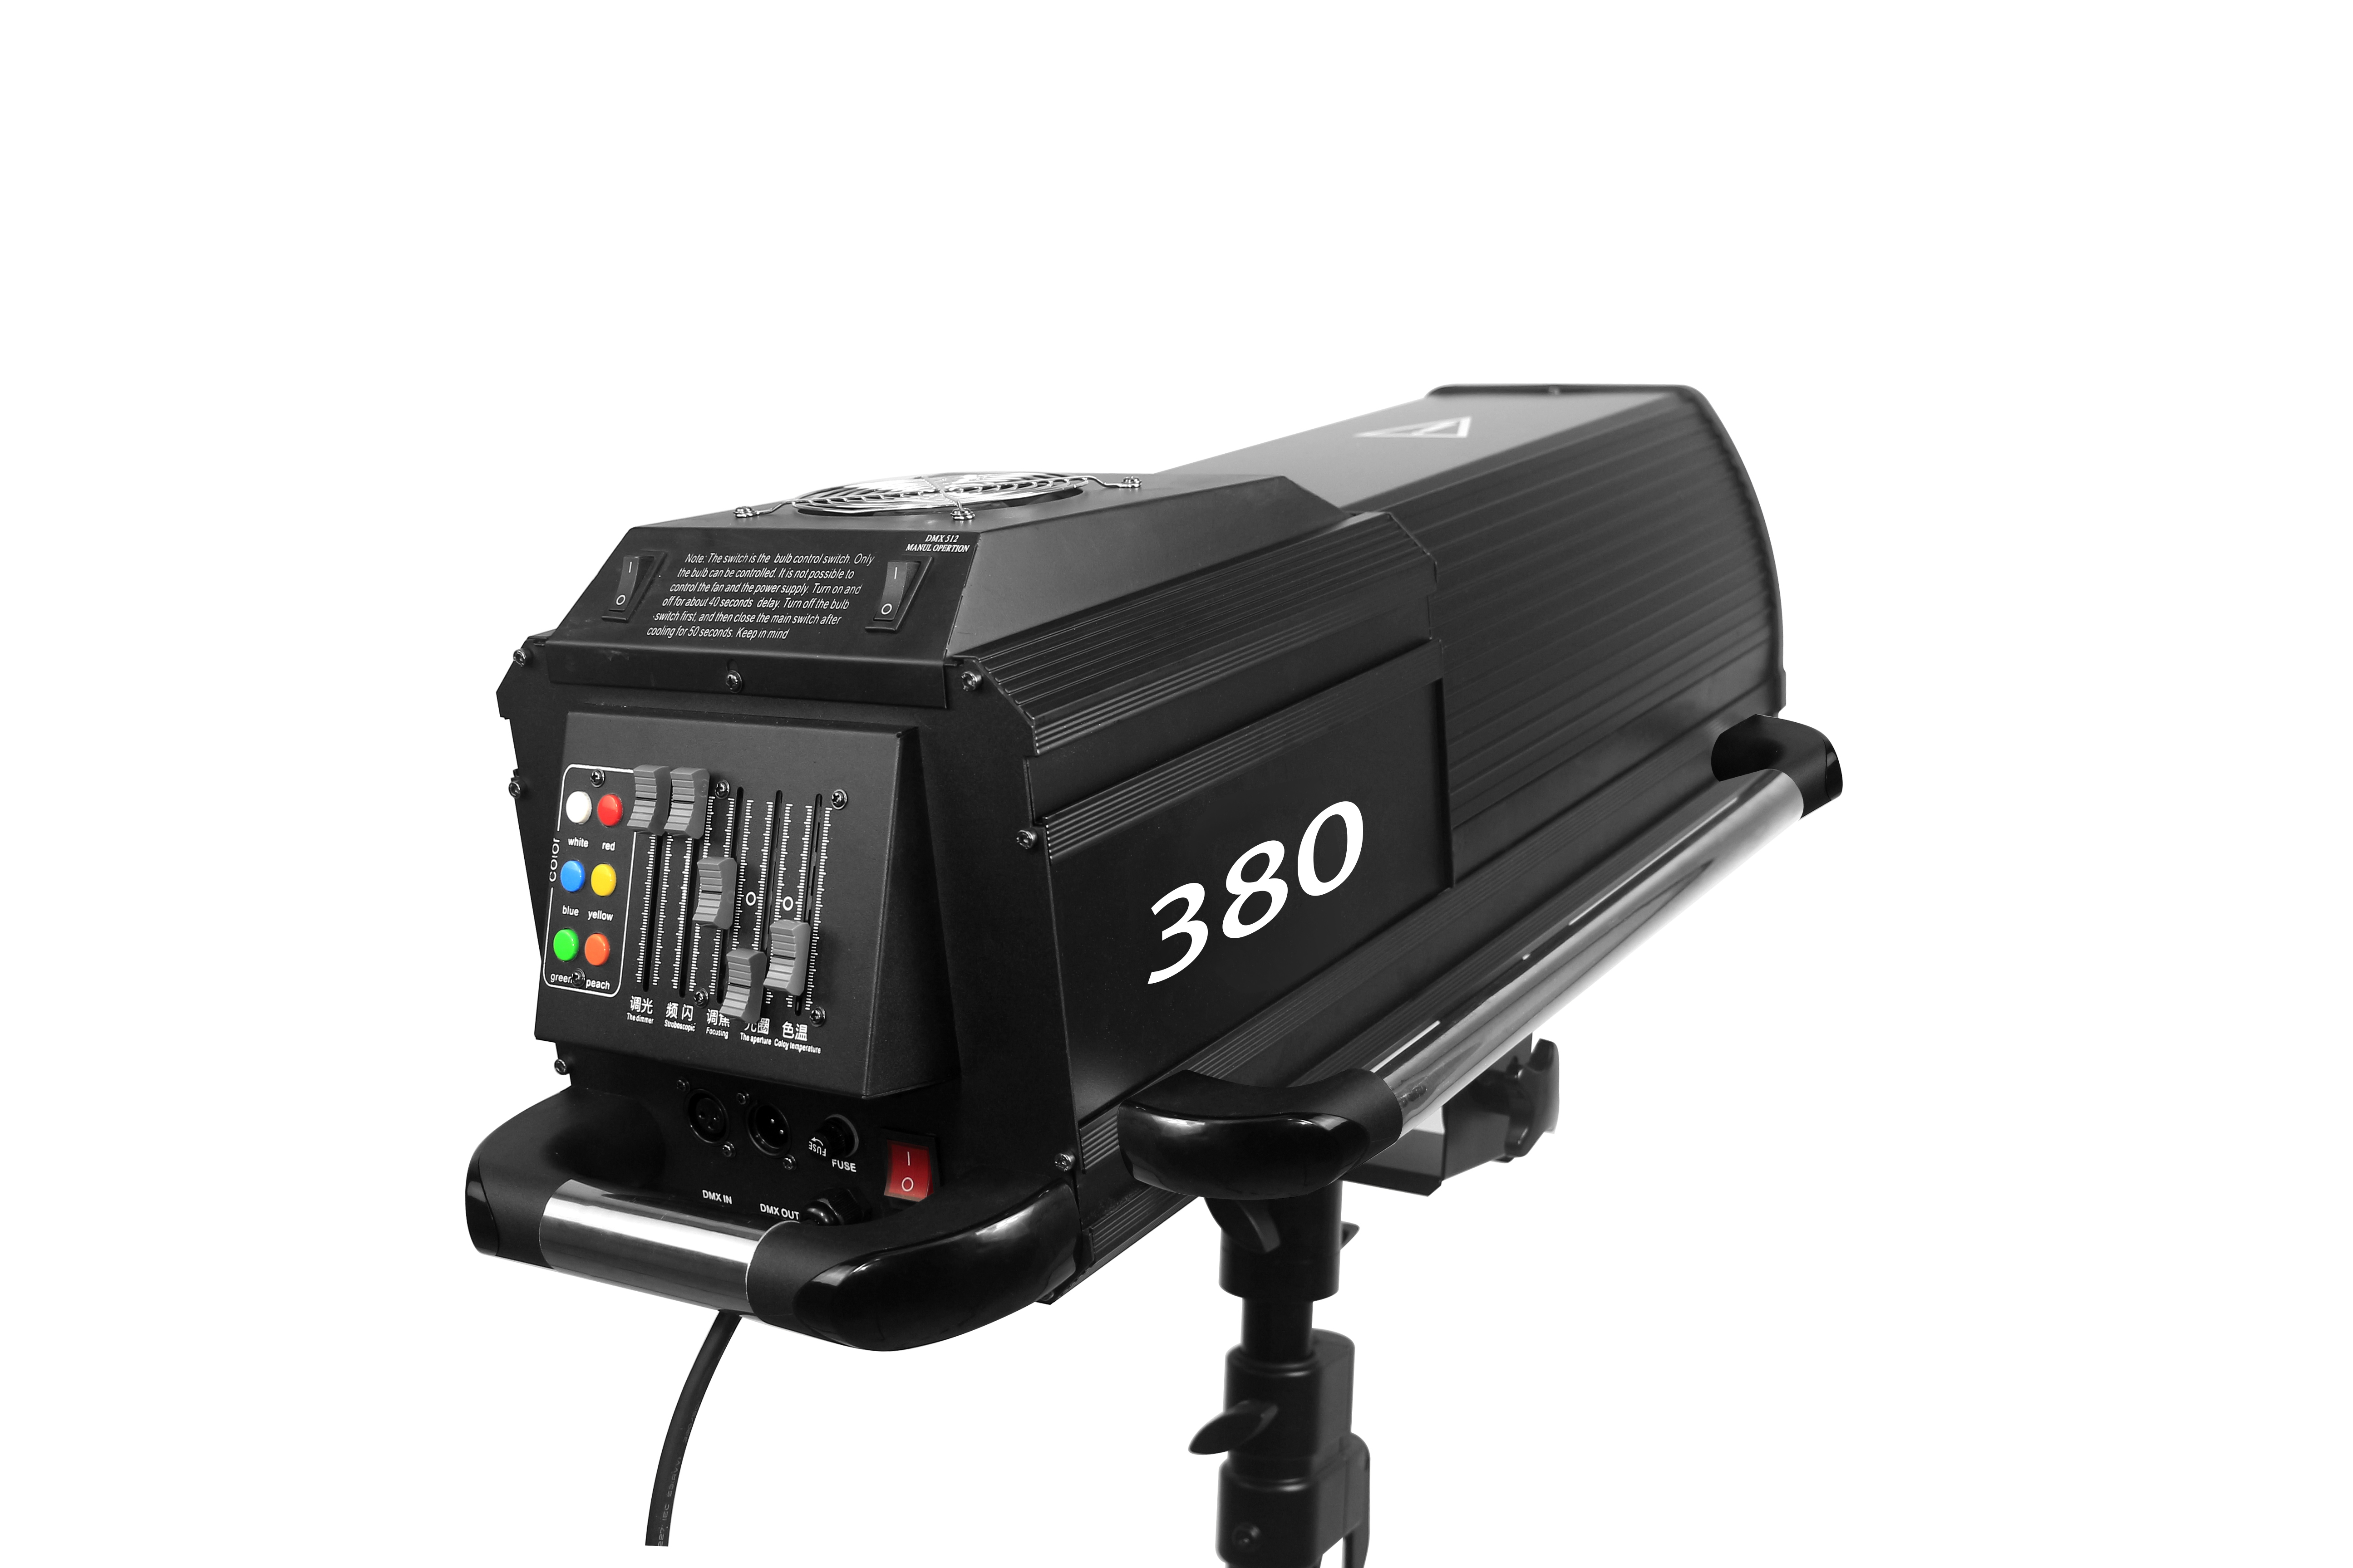

Operation Manual

First of all, welcome to use the 380W high-efficiency follow spot light. For your safety and better use of this light, please read the manual carefully before using it, and operate according to the prescribed procedures, so as not to endanger personal safety and damage the lamp by misuse.
- Product Introduction:
380W follow spot light, made of high-quality aluminum profiles and high-quality carbon-conducting iron, adopts the latest shape design and good optical system, plus two powerful fans, good heat dissipation, high brightness, dimming and various changes in color temperature, zoom is fast. It adopts the general international DMX512 signal, can be used alone or connected to the other machine, can use an external console or its own back console, set the master and salve randomly, two superimposed color chips, and 8 kinds of color changes independently, Add two kinds of color temperature film (3200K 4500K, 6500K), adjustable iris, strobe + dimming function.
- Using Instructions:
After opening the packing box, carefully check whether the lamp is damaged due to transportation, such as whether the screws are loose, whether the lens is broken: when everything is checked, start it. The computer board will perform a self-inspection for about 40 seconds, and the user can only to operate the machine after the self-inspection is completed. (Note: The light source of this light is MSD bulb. After turning on the light, turn off the power after the light is fully on. Wait for about 15 minutes after turning off the power, and turn on the light again after the light bulb cools down. Otherwise, the life of the light bulb will be greatly shortened.)
About its back console please operate according to the button
instructions on the console.
Pay special attention to the black switch on the console, this switch is the DMX512 and the machine self control signal transfer switch.
1 for self control, 0 for DMX512 control. otherwise not subject to control.
The first fader is the COLOR TEMPERATURE fader. There are heating and cooling, plus two colors.
The second fader is the IRIS size fader: after power on, the iris will automatically zoom in and out. Push it up slowly and it will decelerate to 0. When it reaches 0, the iris is the largest and then push it up to manually reduce it.
The third fader the FOCUS fader, move it slowly until the focus is clearest.
The fourth fader is STROBE fader.
The fifth fader rod is the DIMMER fader.
After power on, push up the fifth and fourth fader to turn on the light. Moving down the fourth fader is the strobe speed, pushing the fourth fader to the top, mobilizing the fifth fader for dimming.
The six black circle buttons on the right hand side are color buttons. Each key represents a color.
- Specification：
Voltage: 110V-240V, 50Hz-60Hz
Light Source: Imported light source bulb 380W
Color: 5 kinds of colors plus white light red, yellow, blue, green, warming film.
Beam angle: 8-15 degrees
Strobe 1-7 times per second
Operating function: Iris effect, strobe effect, change color, focus effect
Signal: standard international DMX512 signal
Drive system: 4 powerful fans
Working environment: indoor
Dimensions: 1100x640x580mm
Weight: 50KG
Protection class IP22
Features: This new product. nice appearance. Easy to operate. High brightness, long range. Small size and light weight. Mechanical control, good stability, widely used in bars, wedding banquets, the ideal choice for large-scale performances.
D.Security Directive:
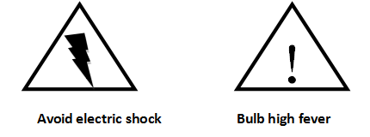
Avoid Electric Shock High Heat Bulb
1. Before repairing, please consult a qualified repair station.
2. When installing and maintaining the lamp, please confirm that the power supply of the lamp body is in the disconnected position
3. Please do not use other power supply, voltage and laser type with different specifications
4. Do not look directly at the light source of the lamp, so as not todamage the eyes

